    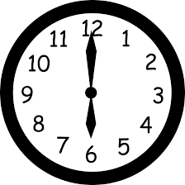  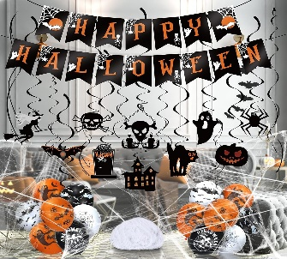 | We are having a Halloween party  30th October  6 -8.30pm
    This Photo by Unknown Author is licensed under CC BY-NC-ND | Fancy Dress is  Harry Potter theme  Buffet food  Spooky games and Disco
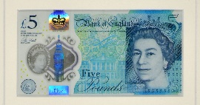   | This will cost £15  Without support  £25 with support on a 4:1 basis  £54 for 1:1 support
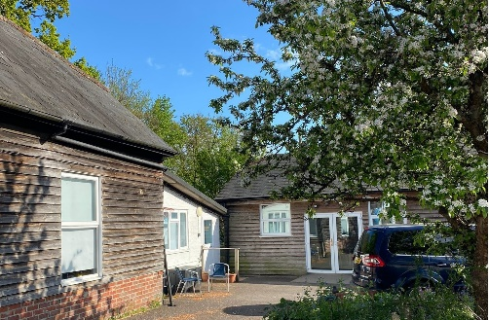 | The party is at Windward  Pick up and drop off from windward

If you would like to come me please send this letter back as soon as possible

Name …………………….

Yes I would like to go. Money enclosed

No thank you

